**AWS CODE DEPLOYMENT &**

**CODE PIPELINE PROJECT**

**NAME: EVANJALIN G**

*INTRODUCTION*

This is our AWS Code deployment and Code pipeline project. Deployed code hosted dynamic websites using AWS Services in the project Ec2, S3, SNS, CloudWatch, Code Deployment and Code Pipeline and IAM to manage and scale a web application. I have used two EC2 instance of Linux. Create IAM roles for protection and developer machine and create IAM user account for project. configure the protection machine and developer machine in the project. In protection machine install code deployment agent on webserver. In developer machine connect IAM user create the code from developer machine. Create code deploy application and Push the code to S3 bucket from developer machine. create deployment group include web server and create deployment to push the code to the server. Create pipeline for automation. its automatically trigger. Test the websites configuration and shows our output.

*OBJECTIVES*

Our AWS Code deployment and Code pipeline project. Deployed code hosted dynamic websites using AWS Services. Install and prepare the Code deployment agent on webserver. Configure the code from developer machine for deployment process and Create pipeline for automatic deployment for new versions. its automatically trigger and shows our output. We will see details in this project.

*AWS SERVICE USED*

AWS service using in the project Ec2, S3, SNS, CloudWatch, Code Deployment and Code Pipeline and IAM. IAM using for roles and user. Ec2 instance used for protection machine and developer machine. S3 used for our scripts storage purpose. SNS used for notifications. Cloud watch used for monitoring. Code deployment used for deployment our project host in a web. Code pipeline used for automation. This aws services are used in our project.

*PROJECT IMPLEMENTATION*

* IAM roles for protection and developer machine and create IAM user for project.
* Configure the protection machine and developer machine in the project.
* In protection machine install ruby & (code deployment agent) installation.
* In developer machine connect IAM user create directory, create sample app.
* Deploy our yaml scripts and start, install & stop comments.
* In index.html enter our Fb source code and save.
* Create s3 bucket for our project enable S3 versioning for our future use.
* Create code deploy application and Push the code to S3 bucket from developer machine.
* Create deployment group include web server.
* Create deployment to push the code to the server.
* Create pipeline for automatic deployment for new versions.
* Enable the simple notification service, Alerting to the user incase if the deployment succeed, failed, start etc.
* Create sns subscription
* Its automatically trigger our CD&CP and shows our output.

*CHALLENGES FACED*

I was faced challenges in indentation error in our Yaml script.

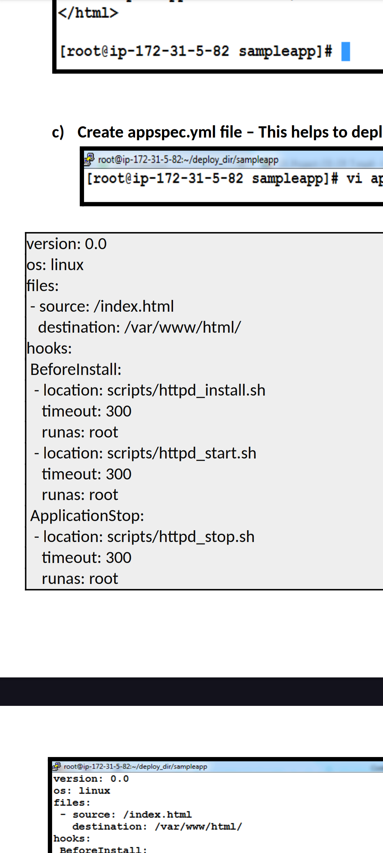

*LESSON LEARNED*

Solving indentation error refers our class recordings.  Checkout errors and solve it and move to next process of the project. We run code and scripts carefully in our project. This lessons I was learned in my project. After sloving indentation errors that script screenshot given below.

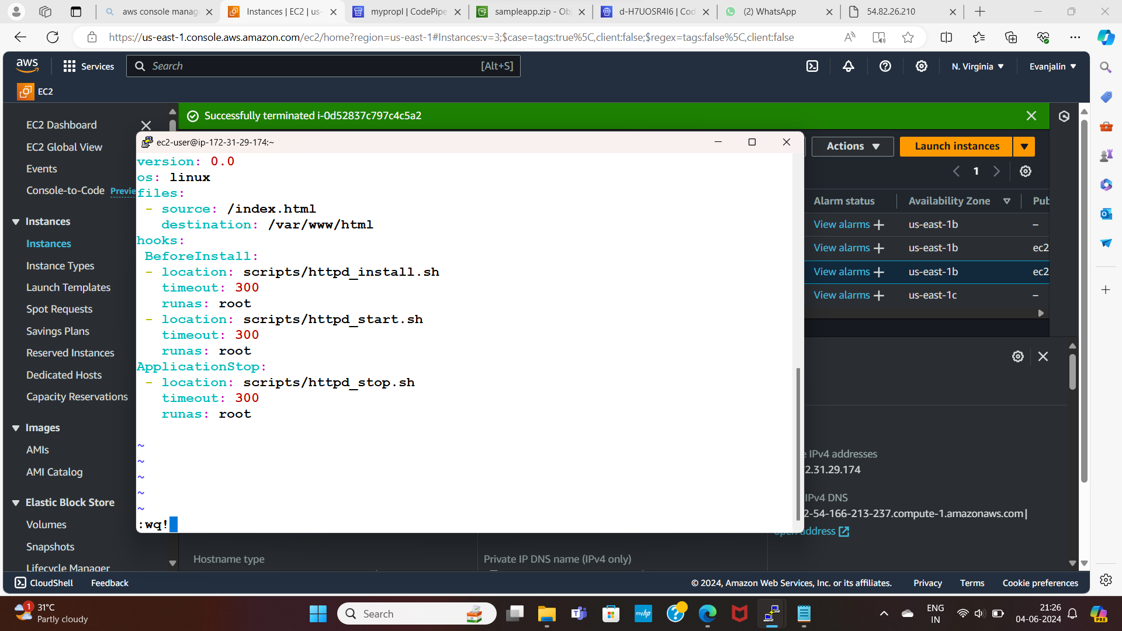

*CONCLUSION*

This is our AWS Code deployment and Code pipeline project. Deployed code hosted dynamic websites for Successfully done. Using AWS services to manage the process, configure the servers and scale a web application. Output screenshots given in next slides.

***OUTPUT SCREENSHOTS***

*CODE DEPLOYEMENT*

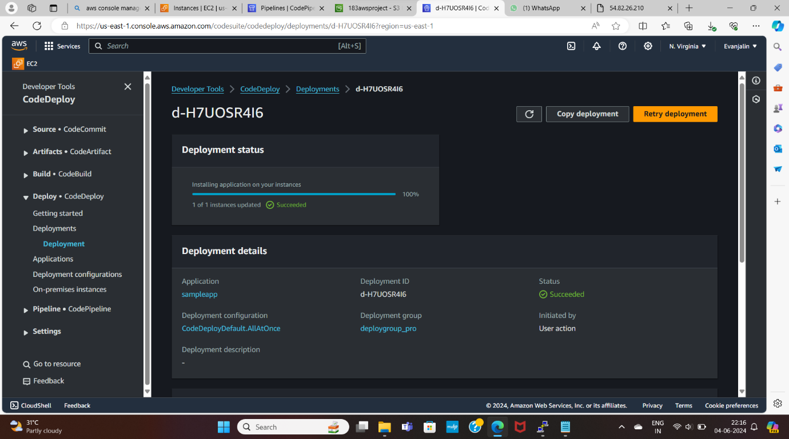

*CODE PIPELINE*

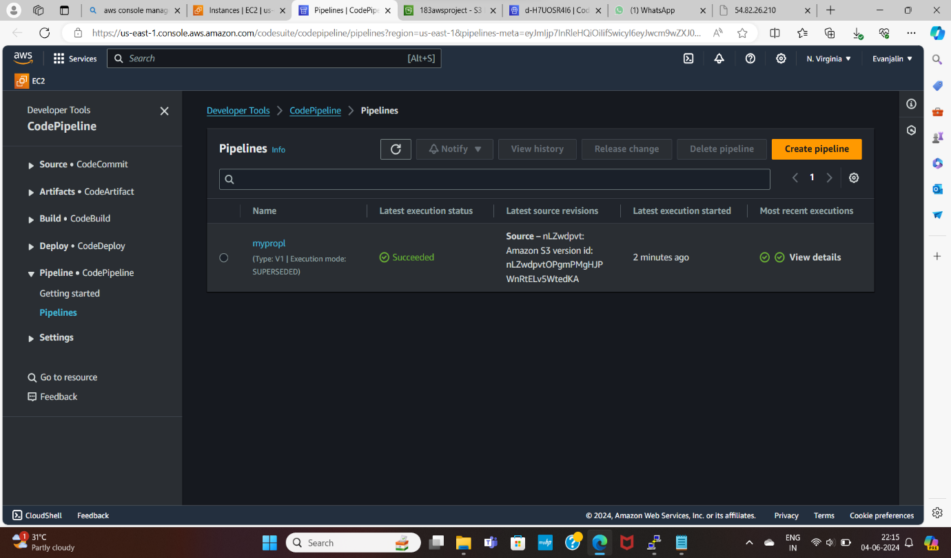

*OUTPUT*

